**Network Time Protocol (NTP)**

* **Network Time Protocol** (NTP) is a protocol that helps the computers clock times to be synchronized in a network.
* This protocol is an application protocol that is responsible for the synchronization of hosts on a TCP/IP network.
* NTP was created by David Mills in 1981 at the University of Delaware. It ensures seamless communication by keeping computer clocks synchronized.

**Types of Modes In NTP:**

**1. Multicast mode:**

* One or more servers periodically multicast the time to the servers running in other computers connected by LAN.
* Then, they set their clocks assuming a small delay.
* This mode can achieve only little accuracy

**2. Procedure-call mode:**

* Procedure-call mode is similar to Cristian's algorithm.
* In this mode, one server accepts requests from other computers, which it processes by replying with its timestamp.
* This mode is suitable for higher accuracy.

**3. Symmetric mode:**

* It is a mode of operation where two NTP servers exchange time synchronization information with each other.
* Both the servers act as both clients and servers.
* Each server sends the time to other server and use the information to synchronize their clocks.

**Working of NTP:**

1. NTP is a protocol that works over the application layer, it uses a hierarchical system of time resources and provides synchronization within the stratum servers.
2. First, at the topmost level, there is highly accurate time resources’ ex. atomic or GPS clocks.
3. These clock resources are called stratum 0 servers, and they are linked to the below NTP server called Stratum 1,2 or 3 and so on.
4. These servers then provide the accurate date and time so that communicating hosts are synced to each other

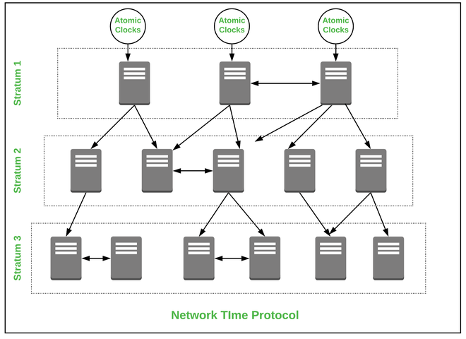

**Applications of NTP :**

* Used in a production system where the live sound is recorded.
* Used in the development of Broadcasting infrastructures.
* Used to implement security mechanism

**Advantages of NTP :**

* It provides internet synchronization between the devices.
* It provides enhanced security within the premises.
* It is used in the authentication systems like Kerberos.
* Used in file systems that are difficult in network synchronization.

**Disadvantages of NTP :**

* When the servers are down the sync time is affected across a running communication.
* Servers are prone to error due to various time zones and conflict may occur.
* Minimal reduction of time accuracy.
* When NTP packets are increased synchronization is conflicted.
* Manipulation can be done in synchronization.